PA Risk

Management Plan

**Template** for managing the risks associated with PA spread

**General Template**

# Contents

Version History 3

Background Information 4

PA National Pest Management Plan 4

Objective 4

Location Map 4

Land Information 5

Proposed Activity (delete if not required) 5

PA Management 6

Risk Matrix 6

Management Recommendations 7

Management Map 8

Conclusion 9

Reporting and Compliance 9

Procedures for PA Management 10

References 10

**Underlined sections are legally required to satisfy rule 4 of the PA NPMP, meaning you must complete these sections if you received written notice that a PA Risk Management Plan is required. All other sections form part of best practice for managing PA. Although not legally required, inclusion of these sections is recommended as part of understanding and implementing kauri protection measures.**

**Version History**

|  |  |  |  |  |
| --- | --- | --- | --- | --- |
| **Plan Version** | | | |  |
| **Plan author:** | | | **Date created:** | |
| **Agency:** | | | | |
| **Inspector or authorised person:** | | | | |
| **Version** | **Author** | **Date** | **Reason for updated** | **Sign Off (occupier)** |
| **1.0** |  | As above | New plan for property |  |
|  |  |  |  |  |
|  |  |  |  |  |
|  |  |  |  |  |

# Background Information

Kauri (Agathis australis) are a cornerstone of the indigenous forests of the upper North Island and have had a large part to play not just in the landscape of Aotearoa, but also in its culture, and early history. To Māori, Kauri are kings of the forest and a taonga (treasure) that connects them and their spiritual world.

Phytophthora agathidicida (PA) is the pathogen that causes disease in Kauri. It was formally identified in 2009 and presumed to be exotic to NZ. PA is a soil-borne pathogen, with no airborne phase and no known cure. Minimising the movement of soil or plant material potentially contaminated with PA by people, their activities and animals is fundamental to the management of disease and the pathogen. Mitigations can be successful if appropriately implemented. Distribution of PA is sporadic, with sections of many forests known to be infected, but many others potentially pathogen free. As there is no known cure greater emphasis is placed on managing our activities in order to control spread of this deadly pathogen.

# PA National Pest Management Plan

A National Pest management Plan (NPMP) for protecting Kauri from *Phytophthora agathidicida* (PA) came into effect on the 2nd August 2022. The plan contains objectives and principles which have been designed to protect Kauri from pathogen and the disease it causes. Included in the plan are 10 new rules. Rule number 4 is in relation to developing disease risk management plans around kauri. This plan has been prepared to satisfy the legal requirements of rule 4 whilst using best practice for managing PA.

# Objective

State the objective of the plan. Include the relevant text of rule 4 objective which can be found in the **How to Guide.**

|  |  |
| --- | --- |
| **Plan objective** |  |

# Location Map

Insert a topographic or aerial image map of the location/property that the PA management plan is applicable to. See **How to Guide** for assistance in producing a location map, an example can be found below.

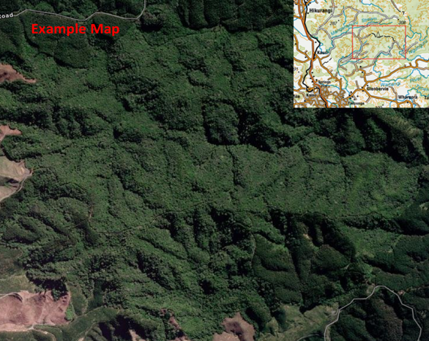

**Figure 1.** Location map

# Proposed Activity (delete if not required)

|  |  |
| --- | --- |
| **Provide a brief description of the proposed activity(s) that are to occur.** |  |

# Land Information

|  |  |  |  |  |  |
| --- | --- | --- | --- | --- | --- |
| **Site Details** | | | | | |
| **Site or property address:** | | |  | | |
| **Locality:** | | |  | | |
| **Landowner(s):** | | |  | | |
| **Contact details (phone and email):** | | |  | | |
| **Current land tenure and use:** | | |  | | |
| **Site or land description (forest, paddock, contiguous, topography, size of forest area)** | |  | | | |
| **Kauri Information** | | | | | |
| **Is the location of Kauri known: Yes** | |  | | | |
| **Can they be avoided:** | |  | | | |
| **Will the activity impact the surrounding land (points to consider, location of kauri, protectable areas, cultural and historical areas)?** | | | *(Delete or write not applicable if the plan is not for a specific activity)* | | |
| **Sampling and Disease Information** | | | | | |
| **Current sampling for *P. agathidicida?*** | | |  |  |  |
| **Previously sampled for *P. agathidicida*?** | | |  |  |  |
| **Description of sampling that’s occurred** | | |  | | |
| **Initial and any subsequent sample dates:**  **:** | | |  | | |
| **Provide a brief description of the health of surrounding kauri not sampled. Include if disease symptoms observed:**  *(Expand for larger forest areas and highlight on map as required).* | | | *(Reporting ill health kauri is required for Rule 1 of the PA NPMP)* | | |
| **History** | | | | | |
| **Describe a brief history of the property and surrounding area** |  | | | | |

# PA Management

This section of the plan describes how the risk of PA spread is identified and managed via the following:

* Risk Matrix identifies the level of risk posed by an activity or a vector (pathway for movement of PA)
* PA mitigations and actions table details how PA is managed for each vector
* The success of PA management comes in the implementation of mitigations or actions.

Risk Matrix

Vectors or activities have been placed in the matrix according to the risk they pose based on relevant factors.(See **How to Guide** – Risk Matrix for full explanation). Some potential vectors are pre-filled, additional vectors may be added.

|  |  |  |  |  |
| --- | --- | --- | --- | --- |
| **Likelihood** | **Consequence** | | | |
| **Minor (A)** | **Moderate (B)** | **Significant (C)** | **Severe (D)** |
| **Certain (4)** | **Mountain bicycles** | **Hunting**  **Stock movement**  **Wild hooved animals** | **Quarrying, machinery** | **Machinery** |
| **Likely (3)** | **Walking on tracks**  **On leash dog walking** | **Off track (into forest on foot)\***  **Horse and horse riding** | **Quad bike use off road** | **Farm machinery – Tractor** |
| **Possible (2)** | **Foot traffic on track** |  | **Tools and equipment**  **Any vehicle on gravel roads** |  |
| **Unlikely (1)** |  |  |  |  |

## *Off track other include: soil sampling, trapping, other?

PA Mitigations and Actions

The table below identifies vector, risk rating, mitigations and actions for this earthwork’s activity (See **How to Guide** and **Appendix 1** for detail on procedures and actions). Add rows as needed.

|  |  |  |  |
| --- | --- | --- | --- |
| **Risk and Description** | **Risk Rating Before** | **Actions to achieve plan objectives (mitigations)** | **Action date or timeframe** |
| **Machinery** Earthmoving machinery  Farm machinery | **Very High** |  |  |
| **Very High** |  |  |
| **Heavy Transport**  Semi-Trailer | **Very High** |  |  |
| **Stockpiling or quarrying**  Overburden, soil, gravel, landscaping material | **Very High** |  |  |
| **Vehicle Use**  Driving on gravel roads | **Medium** |  |  |
| Off road vehicles like quads, motorbikes etc | **High** |  |  |
| **Foot traffic**  Walking on track  Bee keeping  On leash dog walking | **Low** |  |  |
| Off track walking/Placement of traps and trapping/Unauthorised walking track use/Hunting | **Medium** |  |  |
| **Animals**  Access by dogs | **Medium** |  |  |
| Wandering stock | **High** |  |  |
| Wild hooved animals | **Medium** |  |  |
| **Plants and Landscaping** Nurseries  Revegetation | **High** |  |  |
| **Recreational actitivites**  Mountain biking | **Medium** |  |  |
| Horses and riding | **Medium** |  |  |
| **Seasonal activities**  All activities particularly high risk activities. | **Very High** | Dry soil access by carrying out activity or operation in the drier months of the year from late Spring to early Autumn, avoiding rainfall events. |  |
| **Other** | **[insert rating]** |  |  |

## Management Map

Section (4)(c) of plan rule 4 states the information to be provided in a map of the land. See **How to Guide** on detail required for a management map to satisfy this section of the rule.

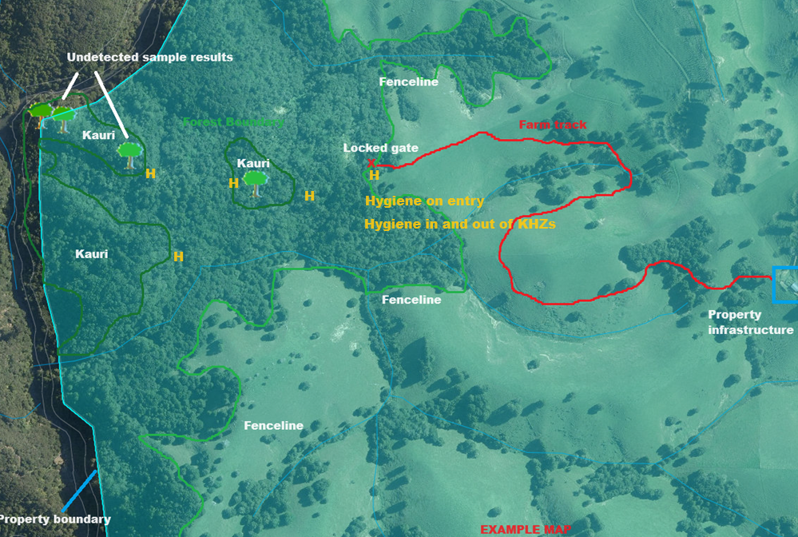

**Figure 2.** PA Risk Management Map containing all the required information

# Conclusion

Provide a conclusion to the plan. **See How to Guide** for assistance.

# Reporting and Compliance

If you have received written notice that a PA Risk Management Plan is required for land you occupy, a completed PA Risk Management Plan must be returned within the specified timeframe and approved by an Authorised Person or the management agency under the National PA Pest Management Plan.

All requested plans (new or updated) must be sent to the following email address: [KauriAuthorisedPerson@mpi.govt.nz](mailto:KauriAuthorisedPerson@mpi.govt.nz), along with the email of the individual Authorised Person that has issued the request (if applicable).

You must also supply the most current version of this PA Risk Management Plan to the management agency, an authorised person or an inspector by the reassessment date specified in the table below (where applicable) and when updates are made to this plan, in addition to alerting of any changes to the occupier responsible for plan implementation and providing any information requested, that is necessary to conduct an audit of plan implementation.

|  |  |  |  |  |  |  |  |  |
| --- | --- | --- | --- | --- | --- | --- | --- | --- |
| **Reporting and Compliance** | | | | | | | | |
| **Landowner to fill out** | | | | | | | | |
| Has the land occupier received a copy of this plan? | | | | | | | |  |
| Does the land occupier understand the requirements of the plan? | | | | | | | |  |
| Name: | | | Contact number: | | | | | |
| Email: | | | | | | | | |
| **Inspector or authorised person to fill out** | | | | | | | | |
| Does the plan comply with Rule 4 of the PA NPMP? Yes/No Initial: | | | | | | | |  |
| If not, why not | | | | | | | | |
| Has non compliance been reported? | | | | | | | |  |
| Date assessed: | | | | Frequency of re-assessment (if required) | | | | |
| Date of next assessment: | | | | Officer Sign: | | | | |
| **Reassessments** | | | | | | | | |
| Date of reassessment: | | Outcome: | | | | Assessor: | | |
|  | |  | | | |  | | |
| **Non-compliance incidence** | | | | | | | | |
| Date | Incidence | | | | Outcome | | Assessor: | |
|  |  | | | |  | |  | |

## **Procedures for PA Management**

Section (4) (d) refers to procedures required to achieve the actions listed and prevent PA spread. At minimum, the hygiene procedures below are required to prevent spread of PA through soil or dirt movement activities. Where further detail is necessary to carry out the actions in the risk mitigation table consistently or effectively add in the relevant procedures below.

Hygiene procedures

* Hygiene for preventing PA spread is achieved by removing dirt from all surfaces that come in contact with the ground followed by sterlising using an appropriate disinfectant.
* Hygiene may also be achieved by using a solution or high pressure wash with a water soluble disinfectant. However, this solution needs to be contained and disposed of appropriately.

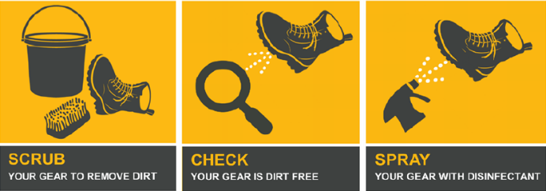

**Figure 3.** Hygiene instructions stepped process

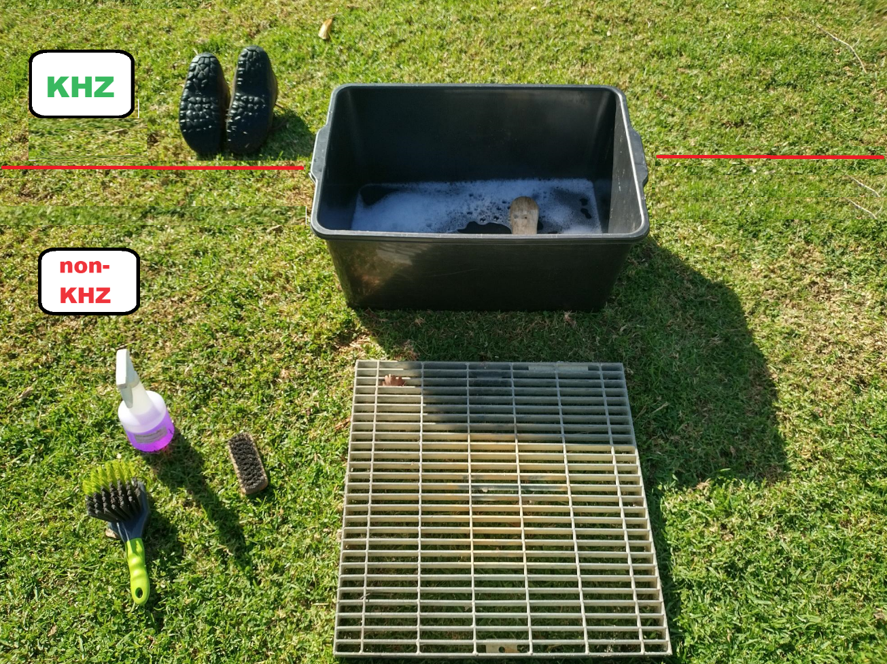

**Figures 4.** A container used for solution wash with grates to stop wet footwear from touching the ground and prevent recontamination (see **How to Guide** for more info)

# References

Provide a references on where information was sourced and or links in the plan. See **How to Guide** for assistance.

**National programme website. Management agency is Tiakina Kauri.**