PA Risk Management Plan

How to guide for development a PA risk management plan

Background Information
This section provides background information on Kauri, the pathogen and disease. Do not delete or alter the content of this section. Reading and retaining this section ensures a better understanding on why risk management plans are required.

PA National Pest Management Plan
This How to Guide has been developed to assist in the preparation of a PA Risk Management plan and to be authorised under the PA NPMP Rule 4.
Underlined sections are legally required to satisfy rule 4. All other sections form part of best practice for manging PA and although not legally required should be included as part of understanding and implementing Kauri protection measures
Rule 4
The PA NPMP Rule 4 PA Risk Management Plan states an occupier of land must have, and operate in accordance with, an approved PA risk management plan if a management agency, an inspector, or an authorised person gives the occupier written notice that the land is at risk of PA.

Objective
Section (3) of plan rule 4 states, the objective of a Phytophthora agathidicida (PA) risk management plan is to detail how the spread of PA will be controlled, how it will be contained to exclude it from any kauri forest; or the effects of PA will be limited. Establishing a Kauri Protection Plan manages the risks and the potential for pathogen spread via activities or vectors.

Location Map
Insert a topographic or aerial image map of the location of the property. Where possible include a higher-level map to identify the general area as well as a lower-level map identifying the earthworks area. Free maps and aerials can be viewed and printed at Arc GIS online or via using Google maps on following link https://support.google.com/mymaps/answer/3024454

Proposed Activity (delete if not required) -
Provide a brief description of the proposed earthworks operation in the table provided. Also state the land occupier as the rule requires the land occupier to develop the plan.

Land Information
Complete the table in the management plan with site, land and landowner detail.

PA Management
The detail in Rule 4 requires procedures to be in place to mitigate the potential spread of PA via vectors and activities. The process of mitigating PA spread involves best practice risk identification followed by understanding procedures and determining the appropriate action to prevent PA spread. This section details the risk, procedures and actions.
Risk management is an important best practice tool for managing PA risk. It’s not legally required in and Earthworks Risk Management Plan but is strongly recommended as part of understanding the process of PA management.

Risk Matrix
The risk matrix indicates the likelihood and consequence of each vector (pathway for movement of PA) or activity spreading potentially infected material based on three factors. These are:
- the volume of soil or dirt that can potentially be moved by a vector
- wet muddy ground conditions that occur in winter, fringes of winter (September to November and May) and immediately after (days) rainfall events between December and April
- frequency of vector over a period of time.

Vectors or activities have been placed in the matrix according to the risk they pose based on the above factors. These are not negotiable unless the operator can provide detail in the plan that:
- the activity will be carried out in summer
- the activity will cease for 3 rainfall-less days after a rainfall event (depending on volume)
- the frequency will be well mitigated by avoidance of kauri and if not then by hygiene
The PA Mitigations and Actions table must accurately reflect the risk each vector poses.
The Likelihood rows represent the chances of dirt containing, or possibly containing, PA from being picked up and moved around. Whether PA is present or not is often unknown so it needs to be managed as if it is present. Unlikely implies its possible but either in small amounts or low frequencies. Highly likely implies that, if PA was to be present in the area, itis almost certainly going to be moved.
The Consequence columns represent the significance of the impact of the introduction of PA either because of the location (directly in or above a KHZ) or the volume of material which in turn implies increase in the possibility of PA being present or volume of PA present.
Tip: The plan writer must replace each vector in the matrix with the specific item being used for the activity. For example: replace ‘machinery’ with ‘12 tonne digger’ if that is a machine that’s being used. If there is uncertainty as to the risk level of a particular vector place it in the matrix as you see fit. An authorised person will review and provide feedback as required.
Risk Matrix Legend
Low | An acceptable level of risk and no further action is required provided that the risk is kept to a minimum
Moderate | Further action required to minimise the risk. Review and implement suitable controls.
High | Immediate further action, possible stop work. Level of risk is unacceptable. Immediate review and implement suitable controls.
Very high | The level of risk is unacceptable and urgent attention is required to reduce the risk. Immediate stop work and revise controls

PA Mitigations and Actions
The table below contains the aspects of the operation, the risk they pose and their mitigations. Complete the table in the plan by copying the mitigations and the new risk rating from the table below.
Risk and Description | Risk Rating Before | Actions to achieve plan objectives (mitigations)
Machinery Earthmoving machinery  Farm machinery | Very High | - Clean yard or a depot. Remove all dirt and vegetative matter. High pressure clean, disinfect.  - Transport to site  - Machinery unloaded clean into KHA  - Set up physical barrier on boundaries of zones.  - Machinery remains in the zone for the duration. Avoid crossing boundaries. Separate machinery for separate zones  - After op, remove loose dirt, vegetative matter without use of water  - Load onto truck for transport  - Carry out appropriate hygiene at yard, depot or cleaning facility
Heavy Transport  Semi-Trailer | Very High | - Transport vehicles to remain outside the KHA unless they have arrived clean to site and remained on sealed surfaces (including compacted gravel).  - Ensure access and turnaround doesn’t impact KHA/Z Transport to depot or yard for thorough hygiene and washdown
Stockpiling or quarrying  Overburden, soil, gravel, landscaping material | Very High | - Material from a KHA must be contained on site  - Cover to prevent movement of dirt via water or wind.  - Excess material can be left in situ depending on the volume and the operation.  - Alternatively, material will need to be transported off site to a suitable location.
Vehicle Use  Driving on gravel roads | Medium | - Carry out a more thorough wash down hygiene at yard, depot or designated facility. High pressure clean, disinfect.
Driving on dirt roads or off road vehicles like quads, motorbikes etc | High | - Clean at car clean place or a depot. Remove all dirt and vegetative matter. High pressure clean, disinfect.  - Park away from KHA/operational area/designated zone and walk  - If vehicle hygiene on site required, identify vehicle hygiene location. Bare in mind proximity to KHA’s.  - Surfaces for parking must be upgraded to prevent water pooling and mud for the duration of the op.  - Consider designating vehicles to zones where possible.  - Carry out an on-site dry brush down/dirt and vegetive matter removal prior to leaving site.
Foot traffic  Walking on track  Bee keeping  On leash dog walking | Low | - Arrive clean leave clean  - Stay on track  - Carry hygiene equipment just in case
Off track walking/Placement of traps and trapping/Unauthorised walking track use/Hunting | Medium | - Temporary stations must contain minimum standard for temporary footwear and tools hygiene station.  - Always use a station temprorary or otherwise (Rule 9 of the PA NPMP)  - Arrive clean, leave clean.  - Scrub and disinfect on entry and exit (Rule 8 of the PA NPMP)  - Carry a hygine kit for hunting and trapping type activities
Animals  Access by dogs | Medium | - Keep dogs on leads. Gently brush paws to remove dirt
Wandering stock | High | - Fence off kauri areas  - Remove stock immediately from forested areas (see Rule 6 of the NPMP)  - Removal must be done as hygieneically as possible
Wild hooved animals | Medium | - Don’t release hooved animals into forested areas containing kauri (see Rule 7 of the NPMP)  - Remove stock immediately from forested areas  - Removal must be done as hygieneically as possible
Tools, Equipment | Medium | - Arrive clean and leave clean.  - On site hygiene is easier to achieve and manage for tools, equipment and footwear.  - Dedicated piece of equipment or boots are recommended per KHA.
Plants and Landscaping | High | - Have a biosecurity plan in place  - Have a production plan in place (Rule 3 of the PA NPMP)  - Set up and maintain good hygiene practices  - Obtain material and plants from reputable source that can deomstrate sound biosecurity practices  - Scrub and disinfect all tools, pots and equipment  - Separate kauri from other plants.
Recreational actitivites  Mountain biking and horse riding | Medium | - Arrive clean, leave clean.  - Scrub and disinfect on entry and exit (Rule 8 of the PA NPMP)  - Carry and use a hygine kit  - Stick to public open tracks  - Avoid muddy tracks in native forest where possible  - Gently brush horse hooves
Seasonal activities  All activities particularly high risk activities. | Very High | Dry soil access by carrying out activity or operation in the drier months of the year from late Spring to early Autumn, avoiding rainfall events.
The last step of the PA mitigations and actions section is implementation. Ensure these actions above are implemented appropriately to meet rule criteria and kauri protection best practice.

Management Map
The purpose of the management map accompanying this plan is to display all aspects required under the Rule 4 definition. This includes the following as a minimum requirement:
- Kauri tree locations
- Signage locations, both for access and hygiene protocols
- Hygiene points, where items contaminated with soil will be washed/cleaned with signage

Conclusion
This management plan covers all aspects of the intended activity or operation that have the potential to move dirt with appropriate procedures and actions to reduce the risk as much is reasonably practicable. The map provided indicates relevant management aspects and with this plan demonstrate how mitigating vectors will be achieved. Auditing of these process will be carried out randomly during the activity or operation. Expand as required.

Reporting and Compliance
See table in PA Risk Management Plan. Answer all the questions. Contact an the management agency, inspector or authorised person to complete their section.

Procedures for PA Management
See section Procedures for PA Management in the Earthworks Risk Management Plan template.

Reference Links
Identify and list the documents used to assist completing this plan. Include research, publications, Tiakina website and council websites. Insert links in plan.
National programme website. Management agency is Tiakina Kauri.
Give Kauri Space to Grow | Tiakina Kauri (kauriprotection.co.nz)
Resources | Tiakina Kauri (kauriprotection.co.nz)
National Plan | Tiakina Kauri (kauriprotection.co.nz)
Principles of hygiene | Tiakina Kauri (kauriprotection.co.nz).
New Zealand legislation website. New NPMP came into effect 2nd August 2022.
Biosecurity (National PA Pest Management Plan) Order 2022 (SL 2022/208) Contents – New Zealand Legislation

Appendices
Appendices in this plan provide additional information which assist in implementing this plan.
Hierarchy of Prevention
Preference | Prevention Measure | Description
Most Preferred | Avoid | Completely avoid kauri forests, stands, hygiene areas, KHA’s where possible. Substitute the location of the operation or time of year to protect kauri by avoidance through substitution.
Most Preferred | Avoid Infected Sites | If avoiding all kauri hygiene areas isn’t possible avoiding known infected sites as a minimum. Sampling and assessment of forest may be required to satisfy this preference.
Most Preferred | Avoid Winter Activities | Avoid operations or activities in and around kauri during winter, late autumn, early spring and rainfall events during the dry months of the year.
Most Preferred | Administrative | Administration measure involves the provision of training, understanding the basic information around pathogen, disease, mitigations and hygiene. Apply this measure in the first instance.
Acceptable | Planning | Consider kauri whilst planning activity or operation. Source background information on kauri, pathogen and disease location.
Acceptable | Hygiene | Follow standard hygiene practice in removing dirt from all surfaces that come in contact with the ground. Once dirt is removed apply suitable disinfectant.
Least Preferred | Hygiene only | Follow the standard of hygiene only without first planning and considering kauri as part of the activity or op. Reliance on practicing excellent hygiene all the times.

How to identify Kauri
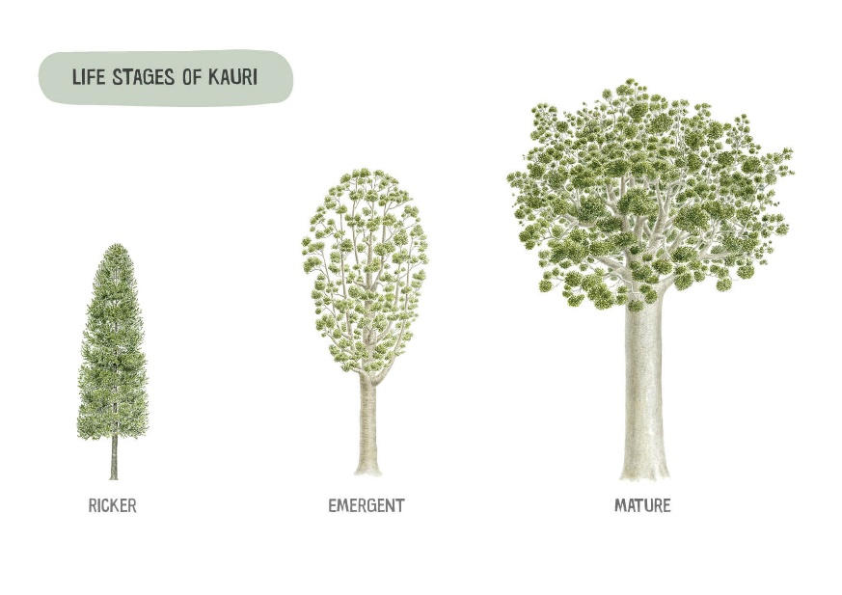
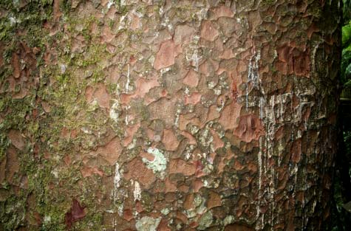 | 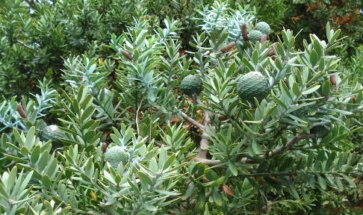
Bark of a Kauri | Female seed cone/green foliage
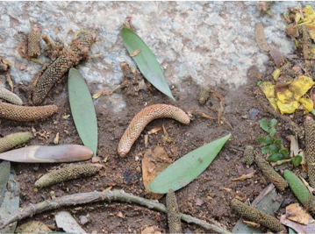 | 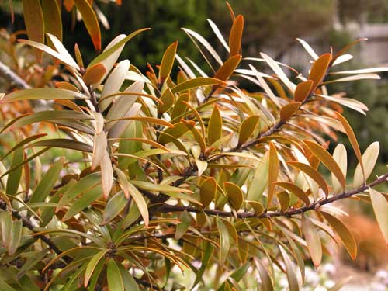
Male seed pod | Varying colours of foliage in saplings

Hygiene Information
Principles of Hygiene - Practicing appropriate hygiene is not the only way to prevent movement of dirt. Other methods include avoiding Kauri, having spare footwear for driving, a pair of boots for each location, dedicated tools or machinery for each KHZ/site, hanging a back pack in a tree, choosing boots with open tread that are easy to clean and using overshoe booties. Reducing the frequency of hygiene through smart planning is recommended. See Principles of Hygiene
Arrive Clean and Leave Clean – this means practice hygiene at a depot or yard before heading to site so you arrive clean. Leave clean either means practice hygiene before you leave site or contain gear and practice hygiene at a depot or yard at the end of the day
Hygiene equipment – either at a temporary station on site or carried in a back pack hygiene equipment must be carried/set up and used. The required equipment for a kit is as follows:
- 1-2x stiff bristle brush  - 500ml spray bottle with disinfectant  - 1x 1L Solo pump sprayer with water  - Boot bag  - Overshoe booties  Consider having a designated pair of boots for working in the KHZ or tools that can be left in the zone to reduce the amount of hygeine. Clean them once then leave them in a container on site in the KHZ so you can put them on before stepping into the KHZ | 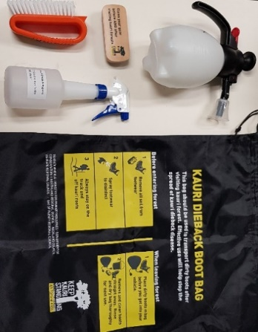
It is recommended to have extra gear in a vehicle. This includes water and disinfectant supply, extra brushes and a container. The container maybe used to contain dirty gear that is to be taken back to a depot for thorough cleaning. Disinfectant can either 70-80% methylated spirits 20-30% water mix or 2% Sterigene. Meths dries quicker. Note: Check the denatured alcohol content from the manufacturer. Some meths are diluted somewhat during manufacture and may not need further dilution as a disinfectant.

Vehicle and Machinery Hygiene
Vehicle and machinery hygiene must be carried out using suitable equipment preferably at a depot or yard. For a temporary on-site station equipment must include a grated platform, sides to contain splash, water and waste tanks, high pressure cleaning equipment and a catchment are to be able to contain, treat and or dispose of run off. The process involves dry removal, then wet removal of dirt via high pressure. Check all surfaces are dirt free and then spray disinfectant on tyres and tracks.
How does a vehicle and machinery hygiene station work? | 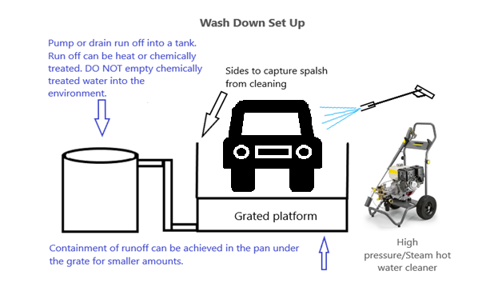
Where do I need to clean on vehicles?  See checklist for vehicle and machinery hygiene | 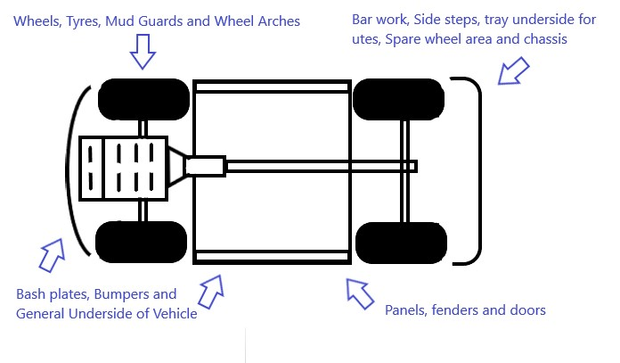
How to identify sick Kauri
The following are symptoms of PA related disease in Kauri.
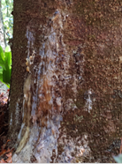 | 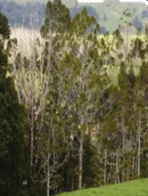 | 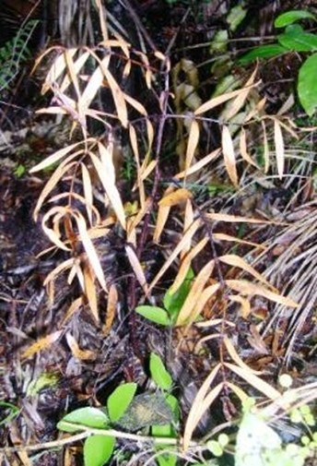 | 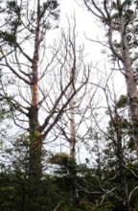
BASE BLEEDING –  This occurs specifically from the base of the tree as the disease progresses up from the root system. | CANOPY DECLINE –  Gradual decrease of branches spreading to the entire canopy. Decline varies from minor to severe. | FOLIAGE COLOUR –  Severe change in colour of foliage from green to yellow to red-brown as the disease progresses. | TREE DEATH –  The tree has succumbed to the disease to its full extent.
Soil Sample Results
Site Soil Sample Results
No. | Sample Name | Sample Date | Easting | Northing | Result
1
2
3
4
5
6
7
8
9
10

Glossary of Terms
Kauri disease | Disease of high death rate in Kauri as of a result of a root rot pathogen.
Pathogen | A bacterium, virus or other microorganism that can cause disease.
Phytophthora agathidicida (PA) | The microscopic, soil borne pathogen which specifically causes disease in NZ Kauri.
Positive | A soil and root tissue sample which has returned as positive result for P. agathidicida at that particular tree.
Undetected | A soil and root tissue sample where the result reflects that the pathogen was not found in the soil at that location and at that point in time. It is not a true reflection of the pathogen or disease status of the surrounding environment.
High risk site | A site that contains a positive result or is near a positive result, contains numerous vectors or one or more symptomatic trees that were not sampled.
Low risk site | Contains undetected samples results with low number of vectors and is not adjacent to a positive result.
Mitigation | The action of reducing the impacts of Kauri dieback disease through the implementation of appropriate hygiene management techniques.
Hygiene management | Recommendations made around the best practice for preventing the spread of soil, infected or otherwise.
PA Management | Prevention of the movement of dirt and pathogen using the risk-based approach and mitigations
Hygiene | Practice of maintaining dirt or soil free footwear, equipment, vehicles and machinery through cleanliness.
Hygiene point | The location on the edge of a forest or Kauri Protection Zone whereby hygiene practices are to be carried out. A hygiene point maybe where a station is established or where hygiene occurs with a personal kit.
Kauri Hygiene Area/Zone (KHA/Z) | The root zone area of a kauri that requires protection and hygiene measures. This area encompasses 3x the drip line of the tree.
Drip line | An approximate line on the ground directly below the outer most branches of the canopy where rain falls from the foliage to the ground.
Vector | a method of transferring infected soil from one area to another. Vehicles, footwear and dirt roads are examples of vectors.

